Farhad Ahmed

Computer Networking

10/16/18

**Lab – TCP Wireshark**

*Running ifconfig:*

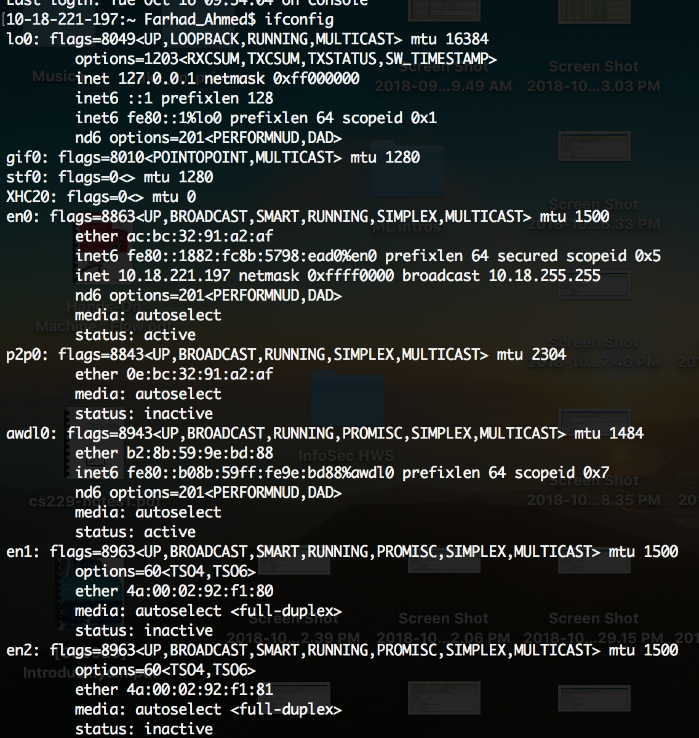

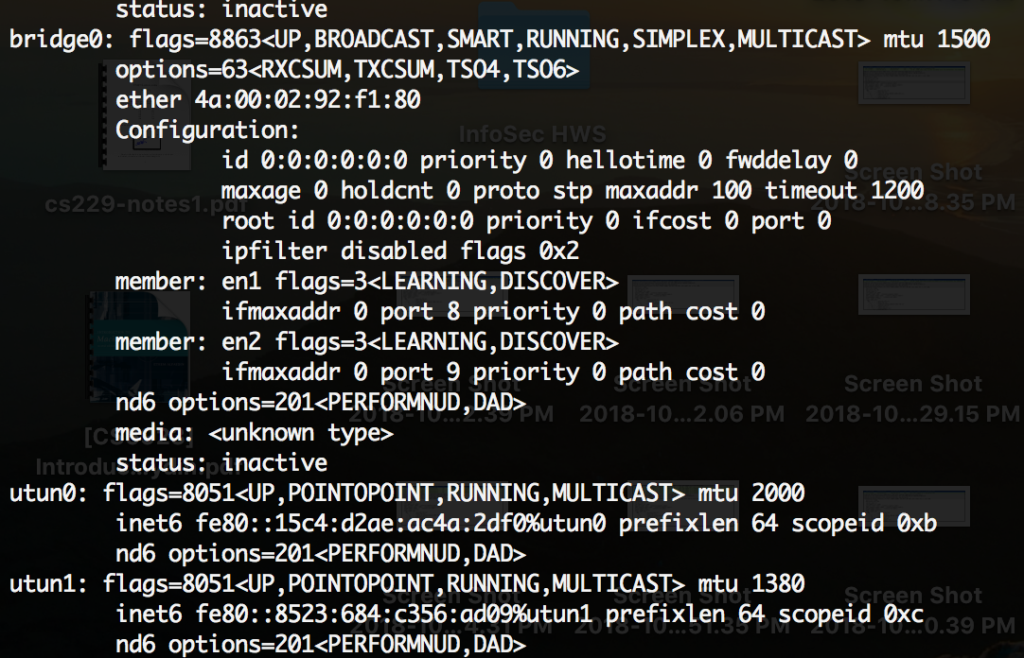

1. The IP address of the client computer is 10.18.221.197 and the TCP port number is 52508.

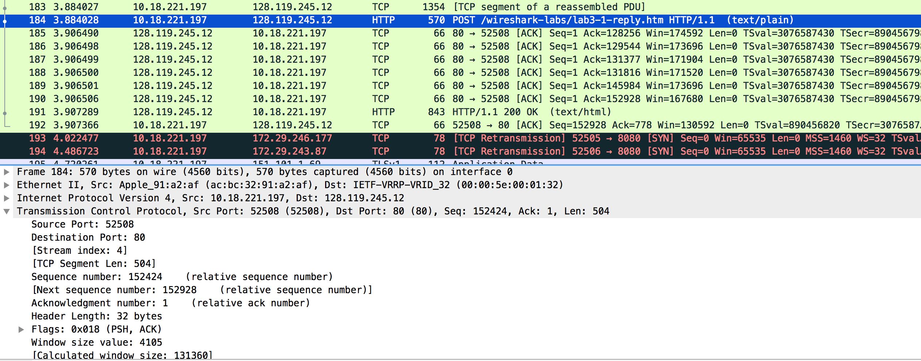

1. The IP address of gaia.cs.umass.edu is 128.119.245.12 and the TCP Port Number is 80.
2. The client’s IP is IP address is 10.18.221.197 and the TCP Port is 52508.
3. The Sequence number of the TCP SYN segment is 0 and the SYN Flag is set to 1 within the flags section which means that the segment is a SYN segment.

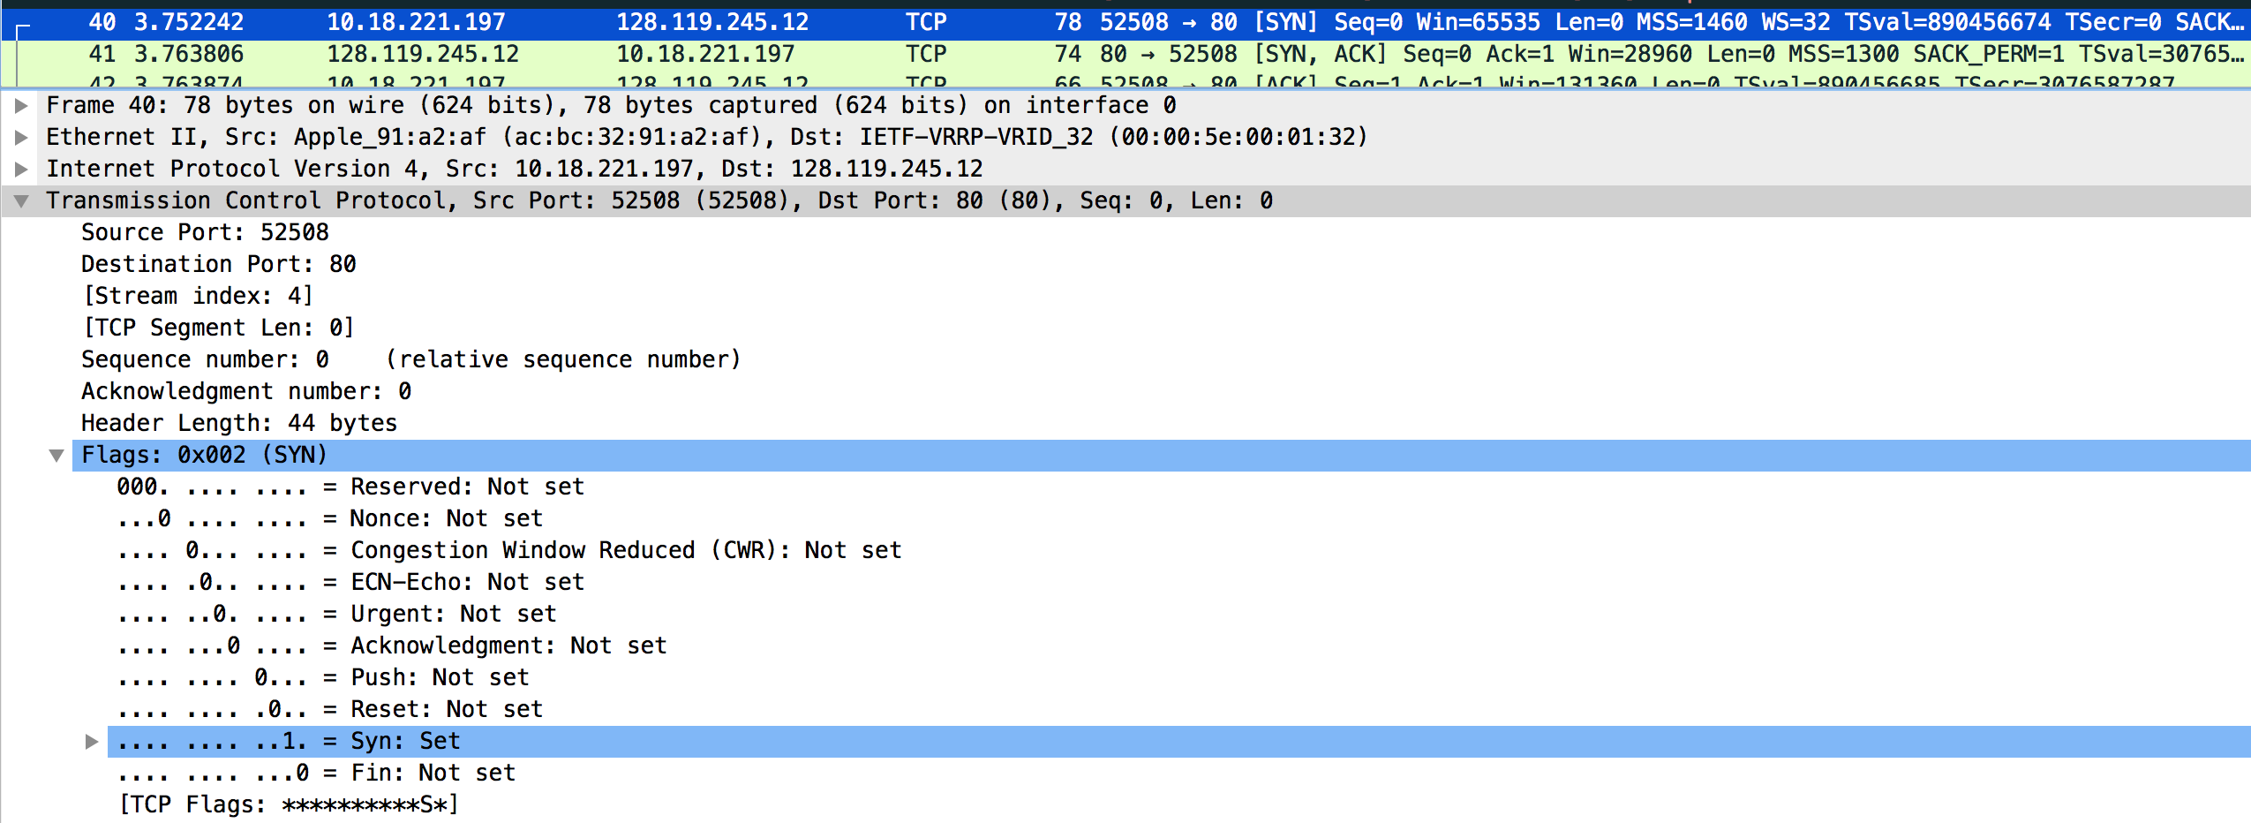

1. The sequence number of the SYNACK segment is 0. The acknowledgement field has a value of 1 within the flags section. It is determined by the server which adds 1 to the initial sequence of number of the the SYN segment. The initial sequence number was from the SYN segment was 0 so adding 1 to 0 yields a value of 1 in the Acknowledgment field. The segment is identified as a SYNACK segment if the SYN flag and the Acknowledgement flag both have a value of 1.

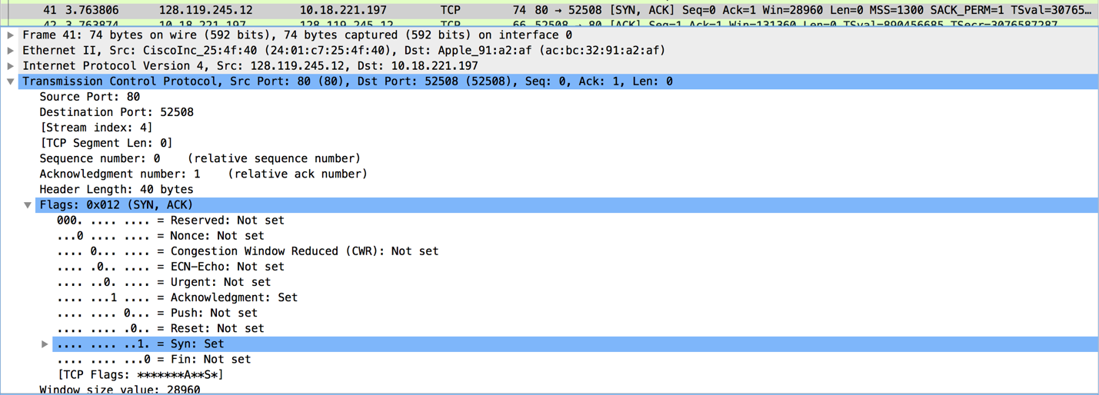

1. Segment number 43 contains the HTTP POST command and it has a sequence number of 1.

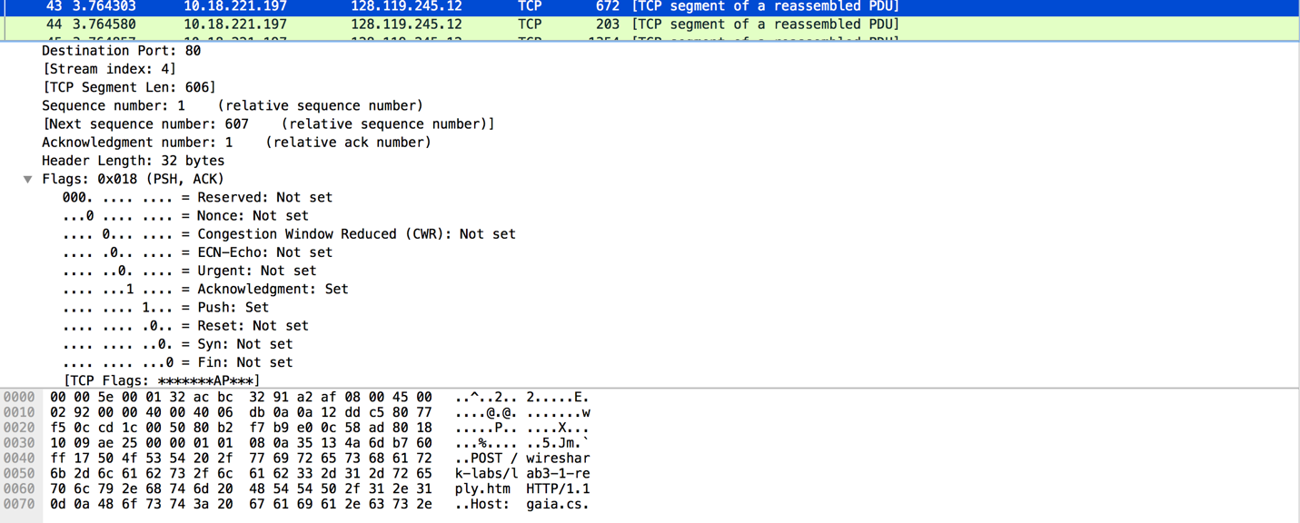

1. Segments 1 - 6 are Numbers 43, 44,46, 54, 62, 72

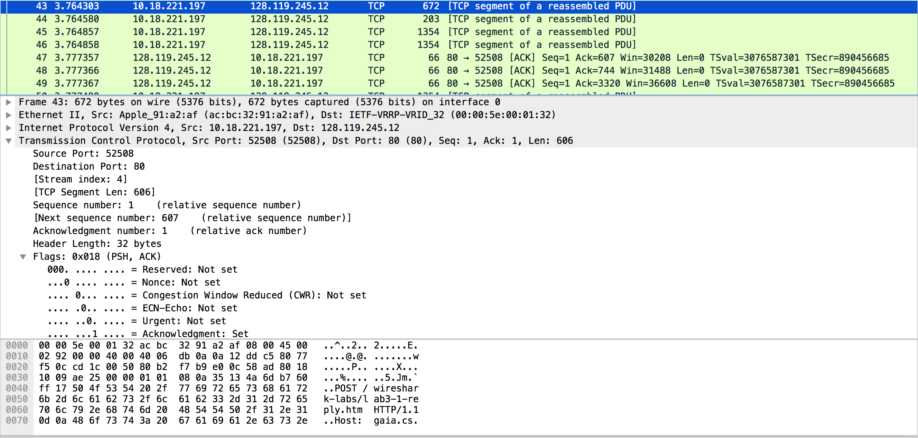

Segment 1 has a sequence number of 1 and ACK of 607.

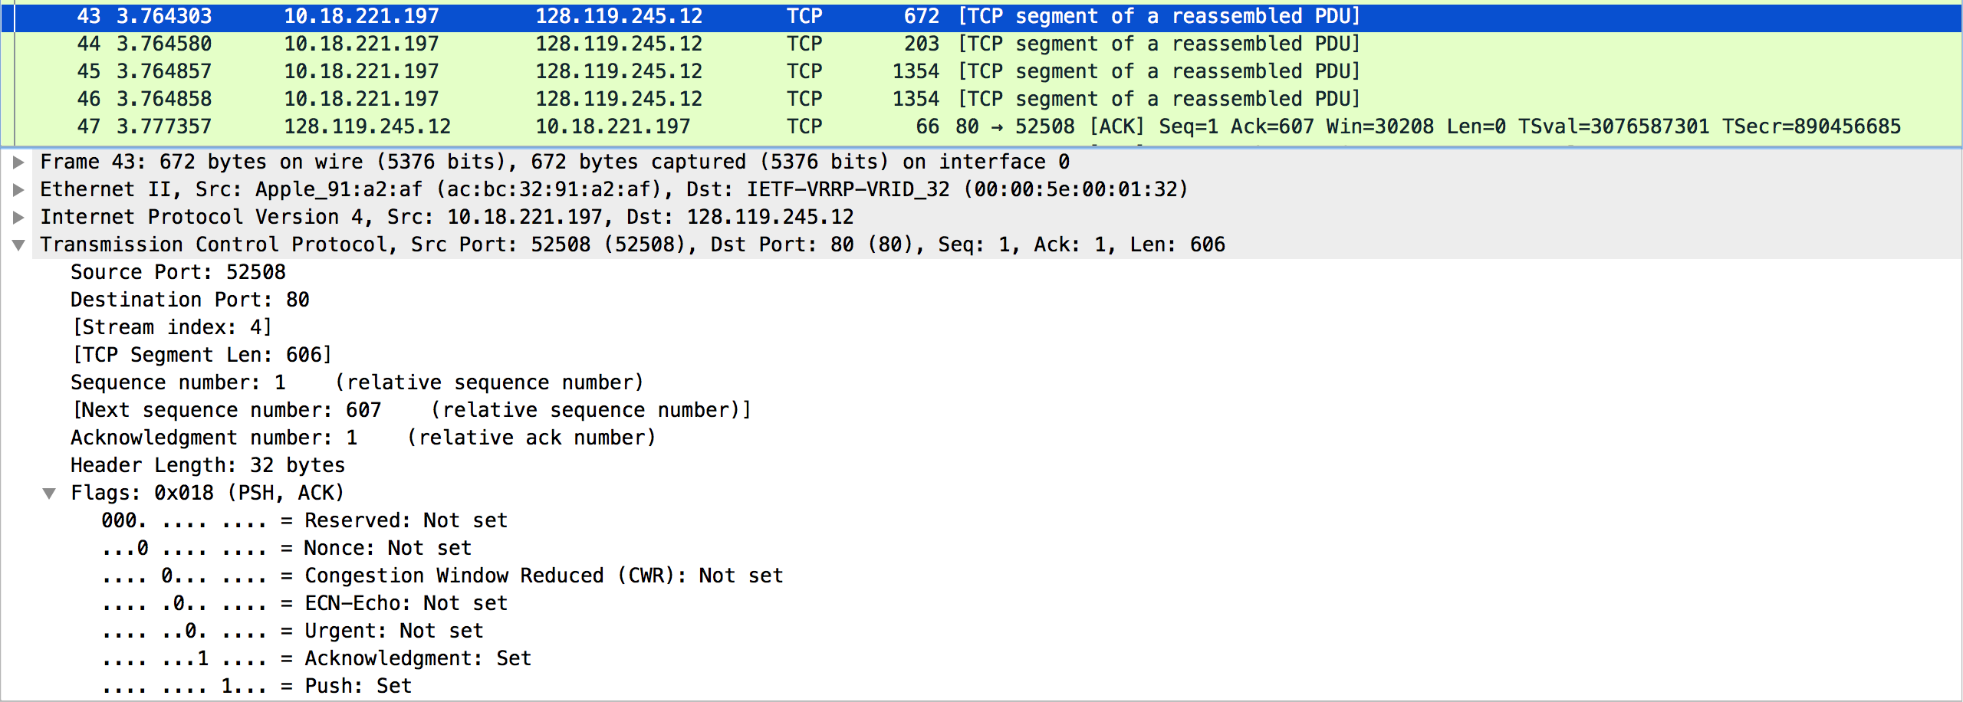

Segment 2 has a sequence number of 607 and ACK of 744.

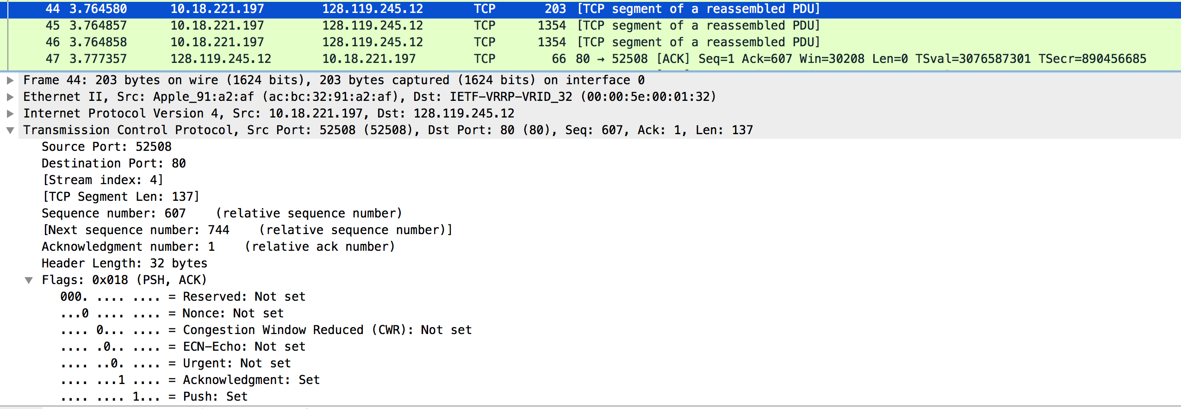

Segment 3 has a sequence number of 2032 and ACK of 18766.

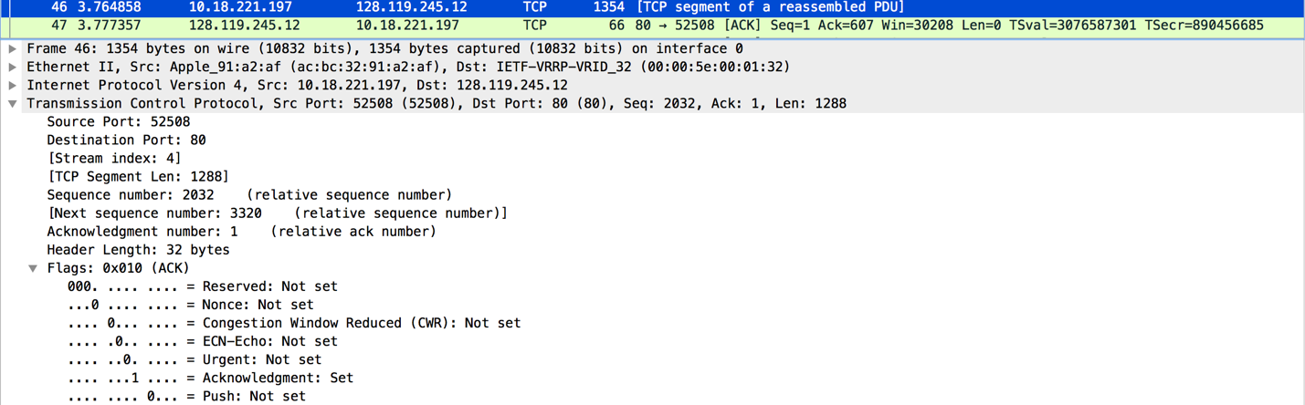

Segment 4 has a sequence number of 8472 and ACK number of 9760.

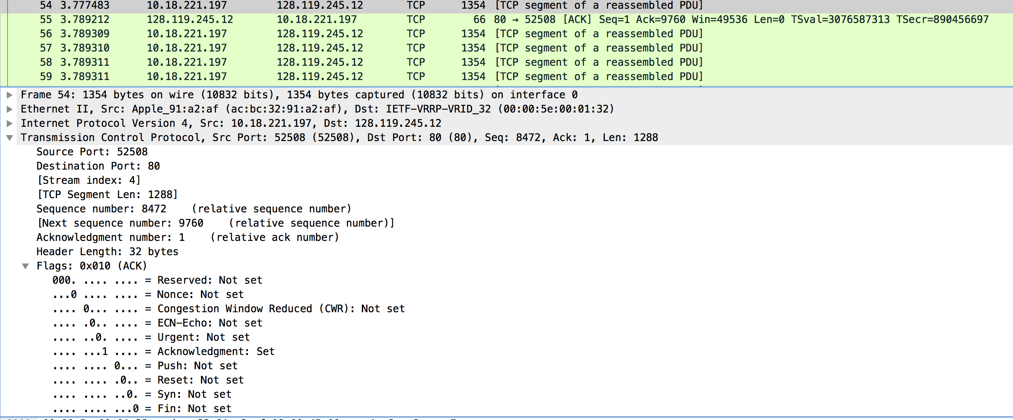

Segment 5 has a sequence number of 4608 and ACK of 18776.

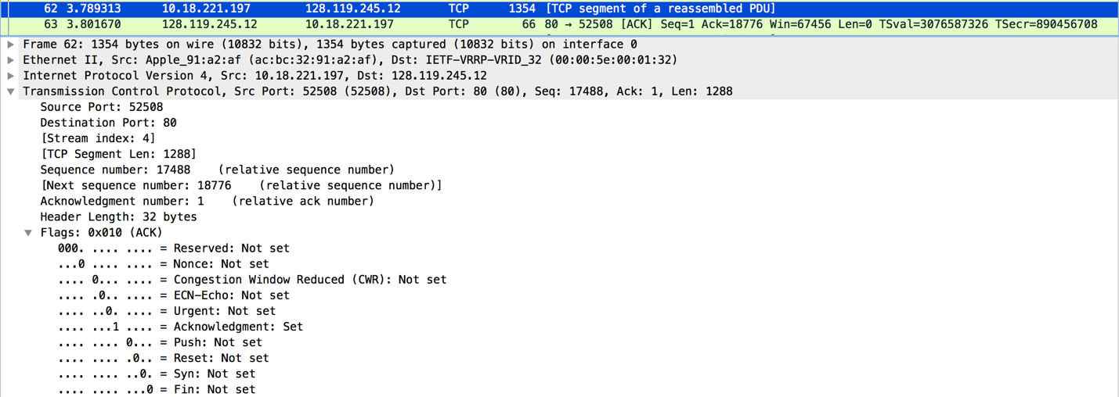

Segment 6 has a sequence number of 2908 and ACK of 30368.

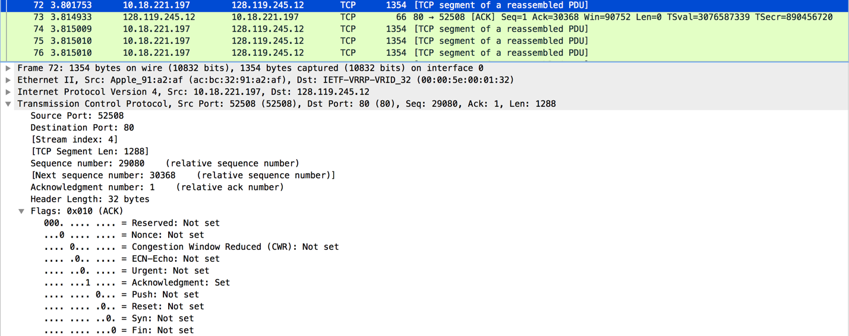

|  |  |  |  |
| --- | --- | --- | --- |
| Segment Number | Time Sent | ACK received time | RTT |
| 1 | 3.764303 | 3.777357 | 0.013054 |
| 2 | 3.764580 | 3.777366 | 0.012786 |
| 3 | 3.764858 | 3. 777367 | 0.012509 |
| 4 | 3. 777483 | 3.789212 | 0.011729 |
| 5 | 3.789313 | 3.801670 | 0.012357 |
| 6 | 3.801753 | 3.814933 | 0.01318 |

Estimated RTT = 0.875 * Estimated RTT + 0.125 * SampleRTT

Segment 1 Estimated RTT = 0.013054

Segment 2 Estimate RTT = 0.01142225 + 0.00159825 = 0.0130205

Segment 3 Estimate RTT = 0.01139294 + .00156362 = 0.01295656

Segment 4 Estimate RTT = 0.01133699 + .00146612 = 0.01280312

Segment 5 Estimate RTT = 0.01120273 + 0.00154462 = 0.01274736

Segment 6 Estimate RTT = 0.01280144 + .0016475 = 0.01444894

|  |  |
| --- | --- |
| Segment | Length |
| 1 | 606 |
| 2 | 137 |
| 3 | 1288 |
| 4 | 1288 |
| 5 | 1288 |
| 6 | 1288 |

1. The minimum amount of available buffer space can be found in the first ACK from the server which has a value of 4105. The maximum receiver buffer size is 131360.

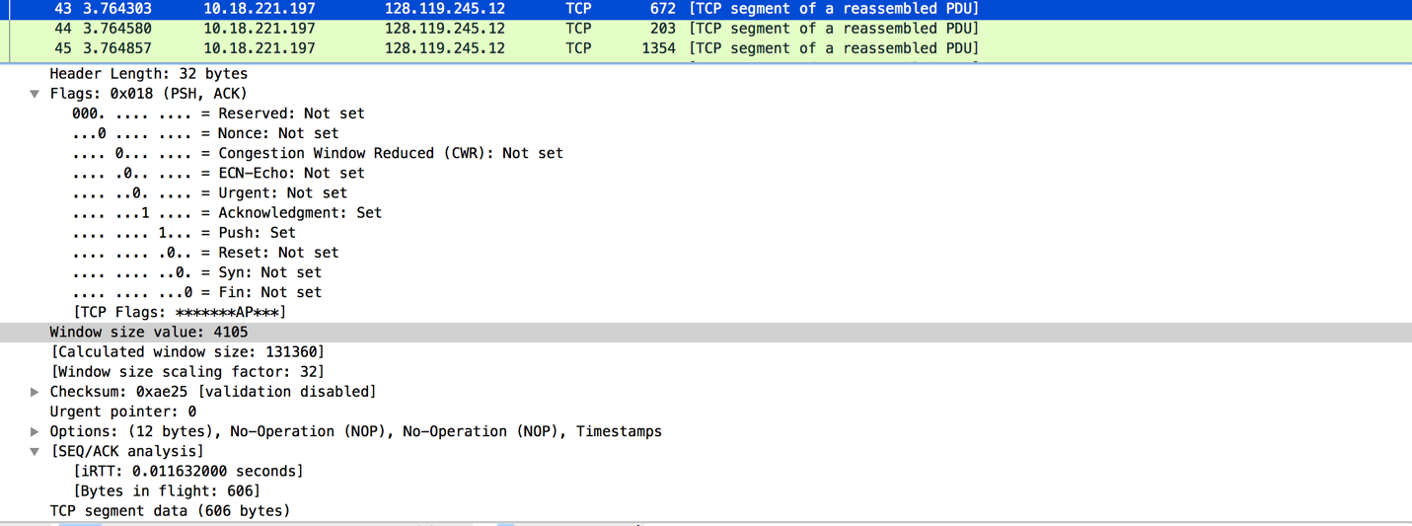

1. There are no retransmitted segments in the trace file as seen in the time sequence graph.

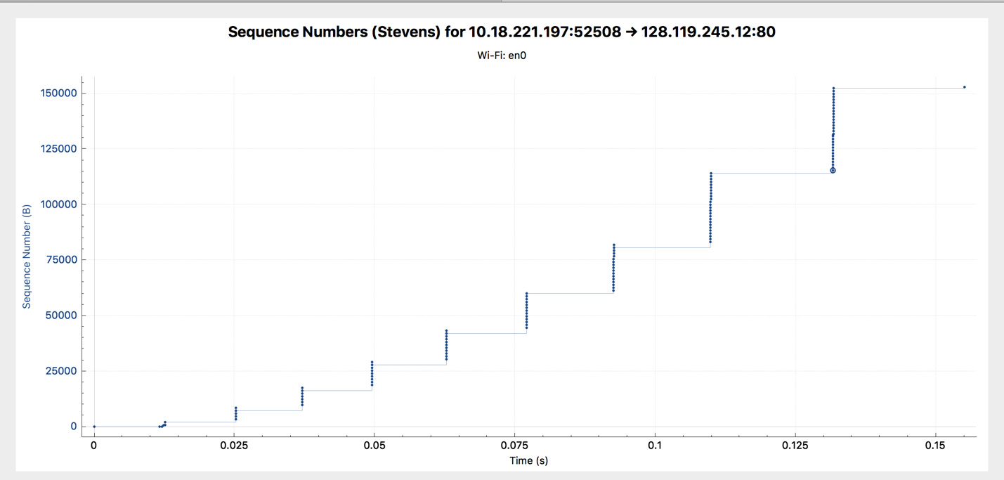

1. The receiver is ACKing every other segment. The data acknowledged was of size 10832.
2. The txt file is of size 152,138 bytes and the download time for the first TCP segment – last ACK is 1.678736 – 0.371257 = 1.307479. The throughput is thus calculated as 152,138/ 1.307479 = 116359.804 bytes per second.



The TCP’s slowstart phase begins around 0.00125 and ends around 0.025. Congestion avoidance takes over at around .093 seconds.

1. The traces used above are the ones for transferring a file to the umass site.